Part 1

Start the system

Create the project container
docker run -it -p 9870:9870 -p 7070:7070 -p 8080:8080 ^
--name sic-2025-project --hostname group10 ^
--mount type=bind,source=.,target=/share ^
--memory 4g --cpus 4 ^
trungphansg/sic-project:latest
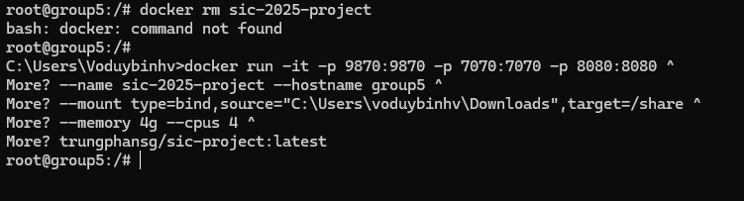

Introduction
?

Change the pyspark’s prompt
nano ~/.ipython/profile_pyspark/ipython_config.py

Exit from the container
exit

Open the project’s terminal
Open the Windows’ Command Prompt, and execute the command:
docker exec -it sic-2025-project bash

RDD

Spark Shell

Open the pyspark shell
pyspark
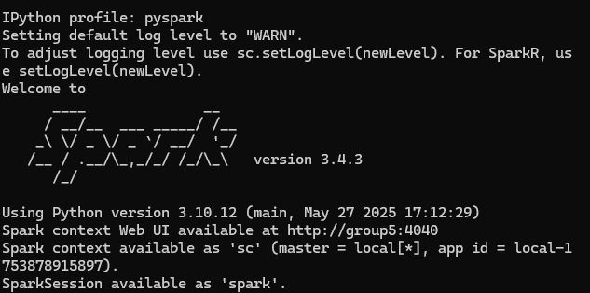

Create an RDD from the range from 1 to 100. View the number of partitions and data in each partition.
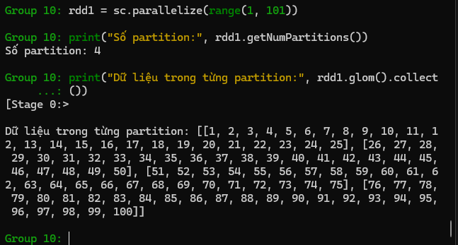
Em ghi lộn group 10 em group 5

Create an RDD from the range from 1 to 100 with 4 partitions. View the number of partitions and data in each partition.
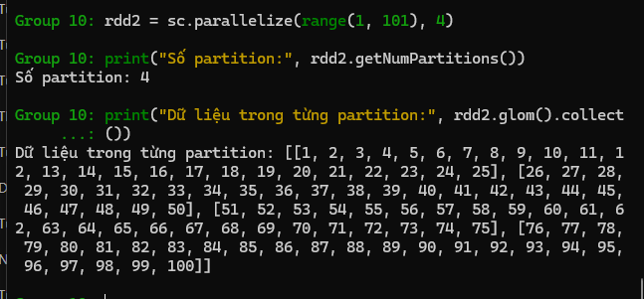

Calculate s = 1 + 2 + … + 100.


Calculate s = 1² + 2² + … + 100².
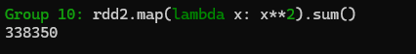

Calculate s = 1³ + 2³ + … + 100³.
? 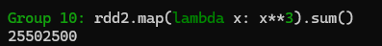

Calculate the sum of values in the data1.txt file.
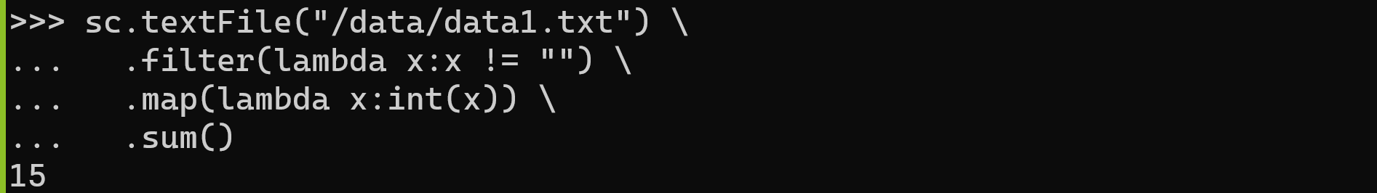

Calculate the sum of values of the second column in the data2.txt file.
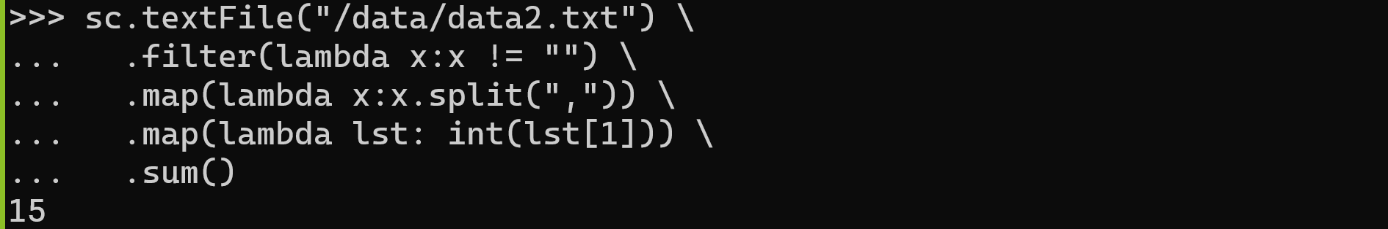

Calculate the sum of values in the data1.txt file in HDFS.

Preparing data
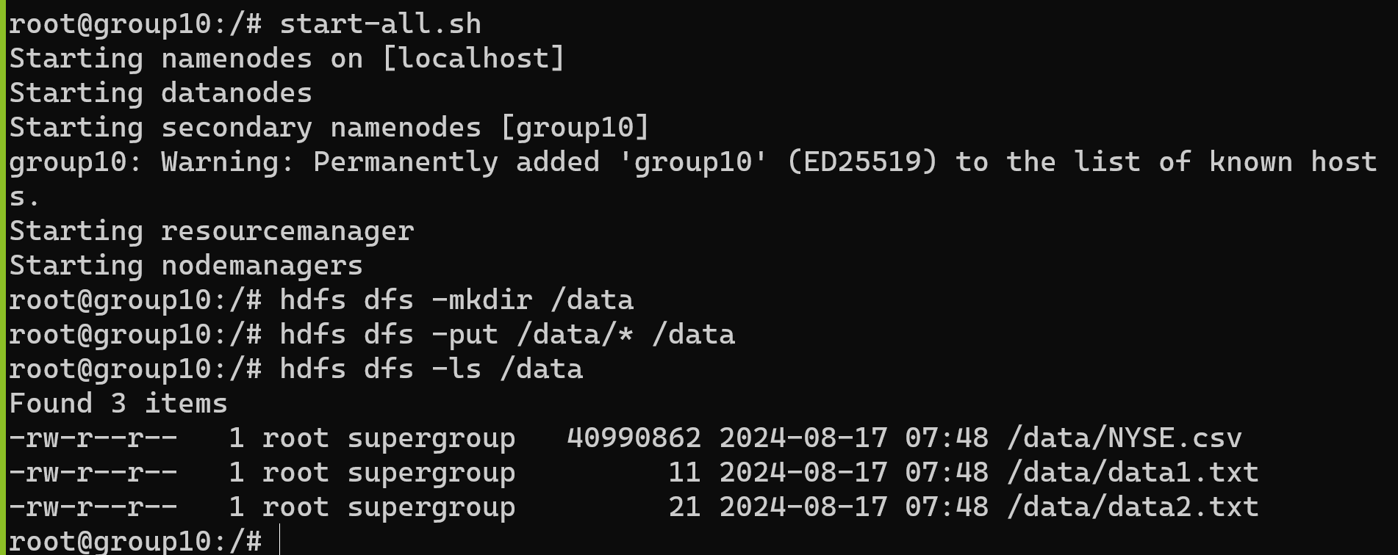

Caculate the sum
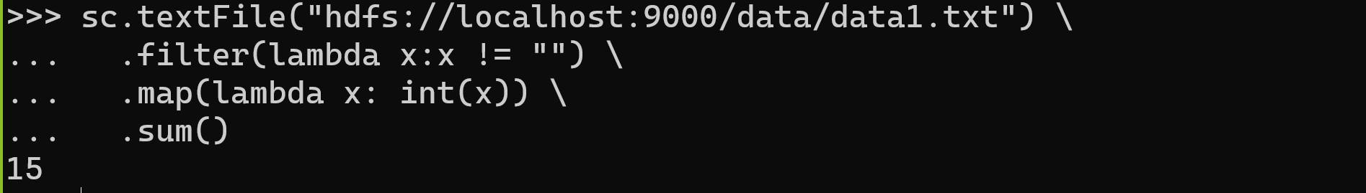

Calculate the sum of values of the second column in the data2.txt file in HDFS.
? 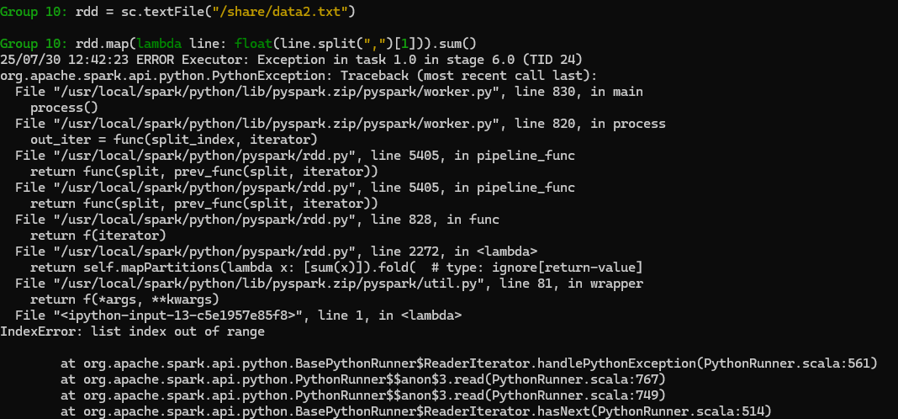

Calculate the total trading volume of AEA stock in the NYSE.csv file in HDFS.
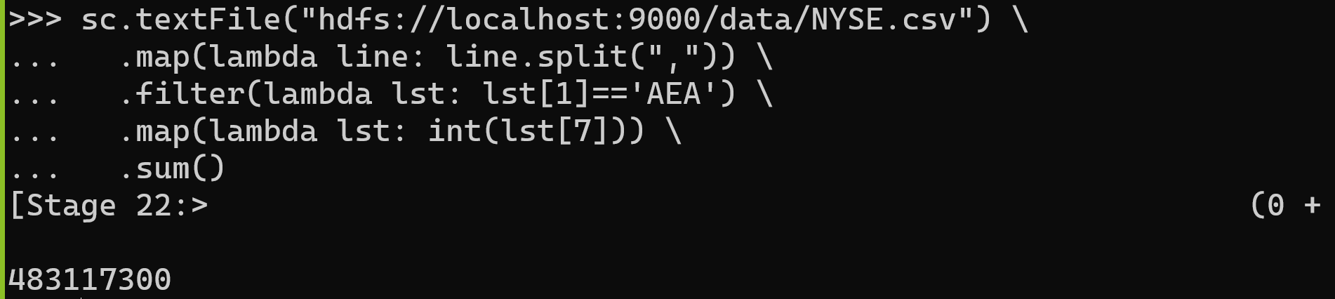

Calculate the min, max, mean of the trading volume of AEA stock in the NYSE.csv file in HDFS.
?

Calculate the total trading volume of AEA stock in the year 2010 in the NYSE.csv file in HDFS.
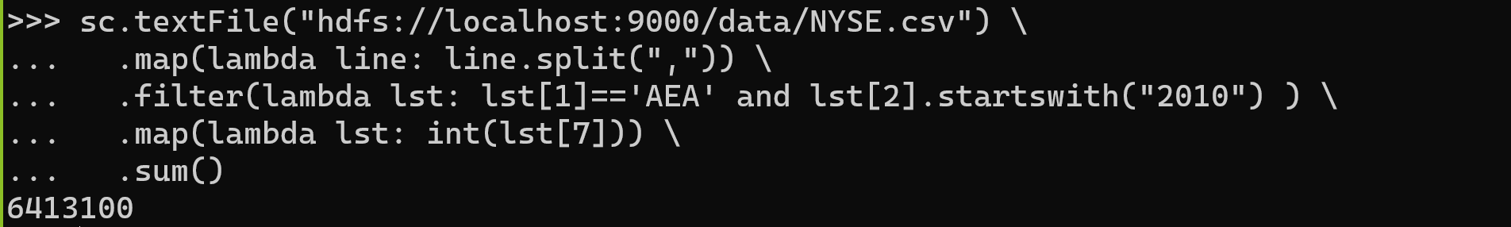

Calculate the total trading volume of all stocks in 2009 and 2010 in the NYSE.csv file in HDFS.
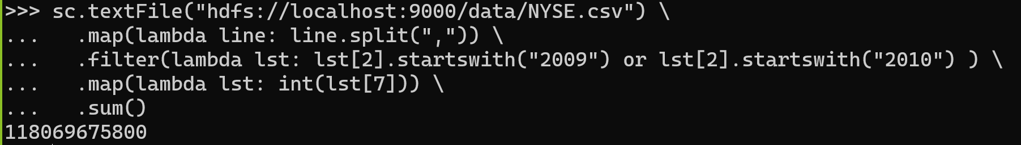

Calculate the total trading volume of AEA stock in 2009 and 2010 in the NYSE.csv file in HDFS.
? 